**IBM APP Connect Installation**

1. Login to the OpenShift Console with the provided URL. Once logged in click **OperatorHub** under **Operators** menu.

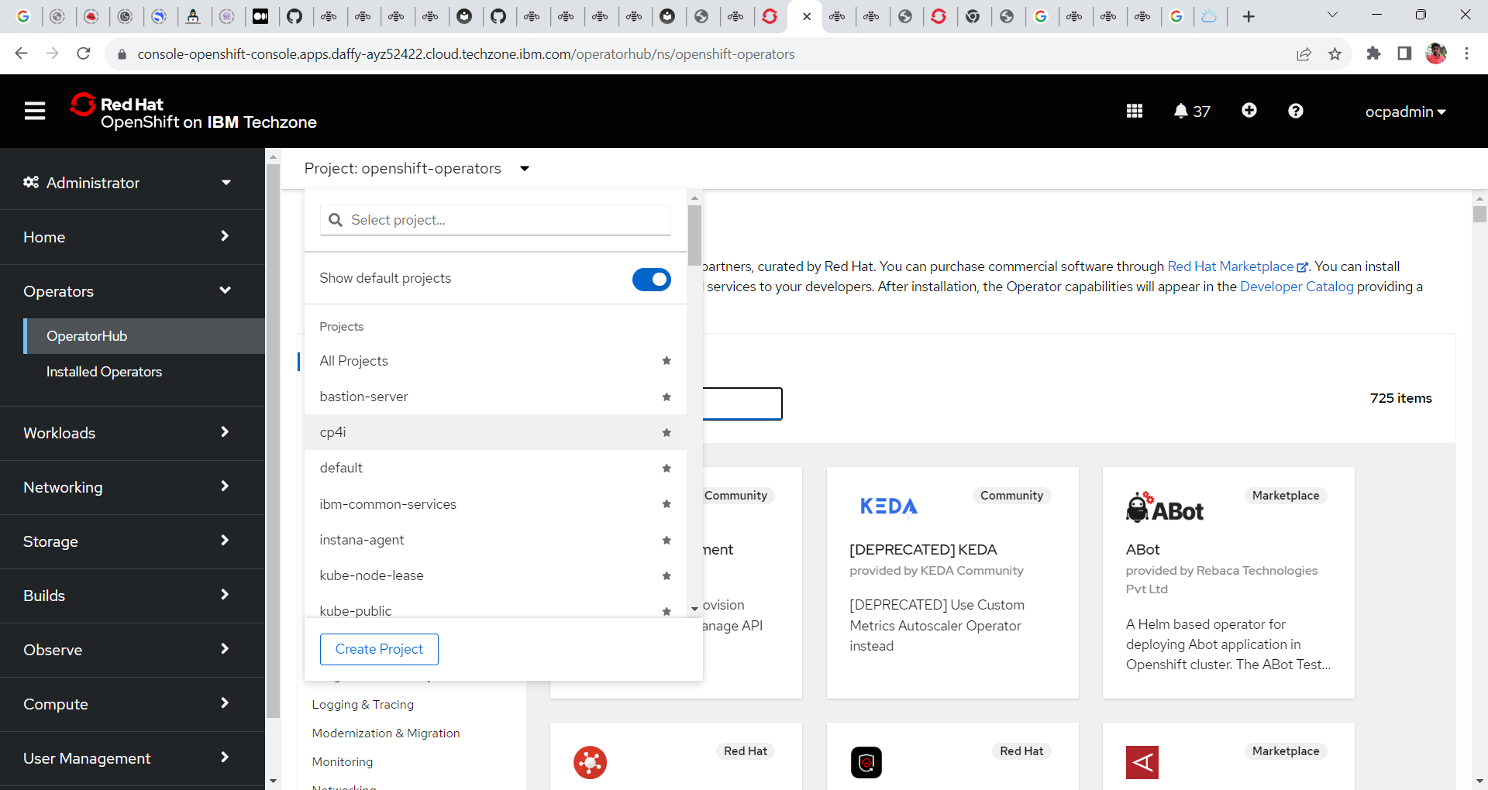

2. In the operator hub search for the tile **IBM App Connect** and click on it.

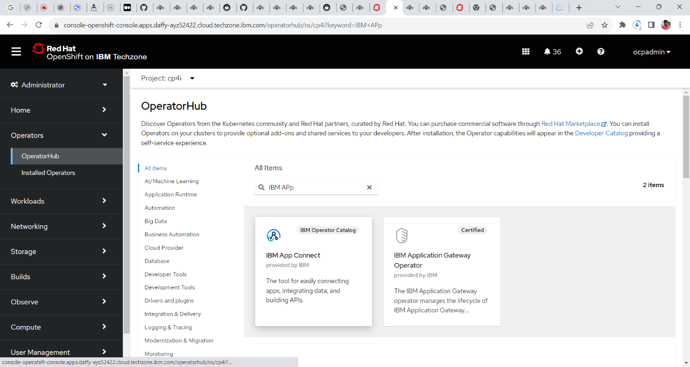

3. Read the document and click on the **install** button.

5. In next window select the following configuration

**Update Channel =v5.0-lts**

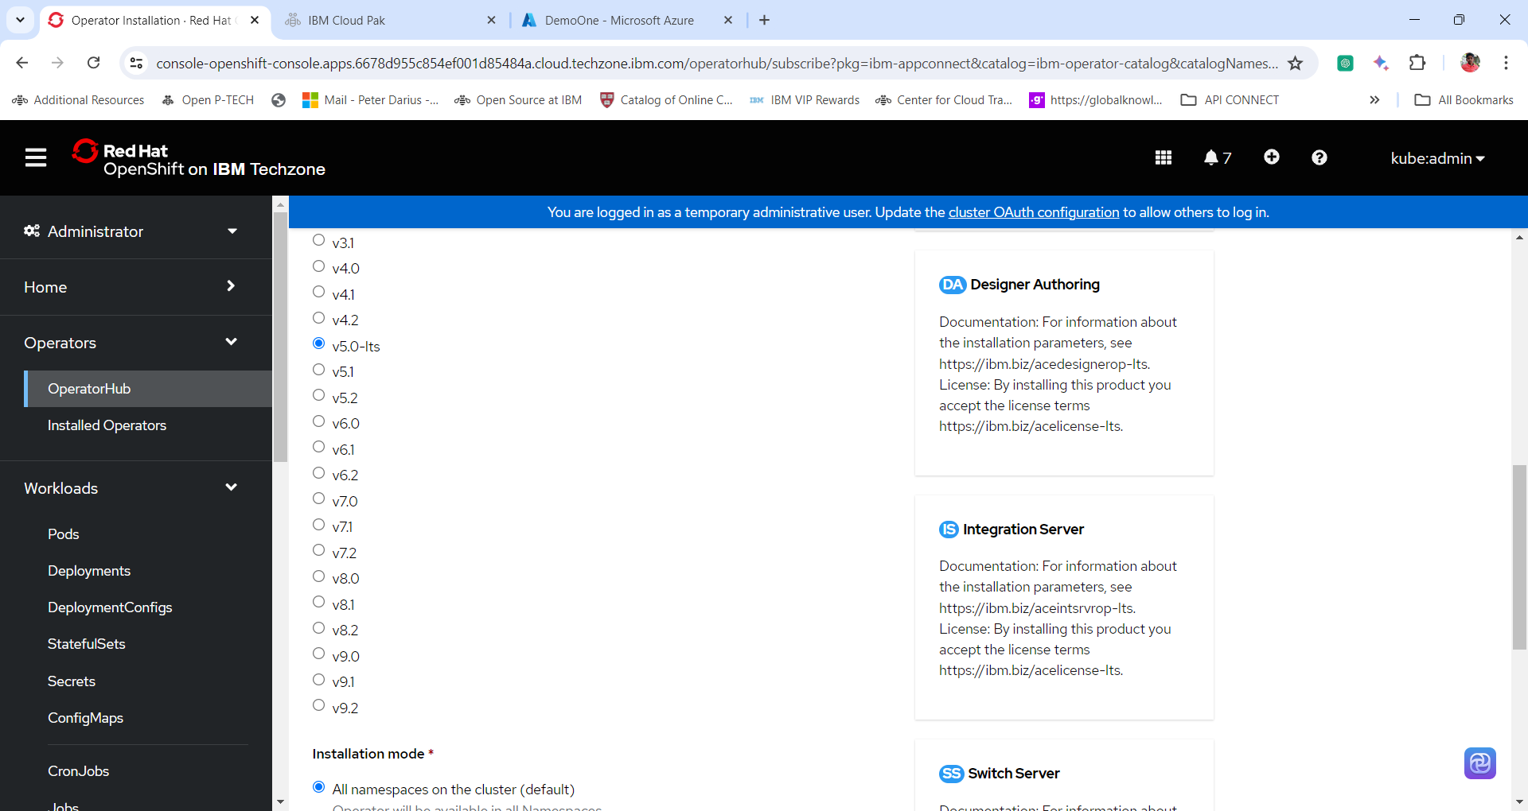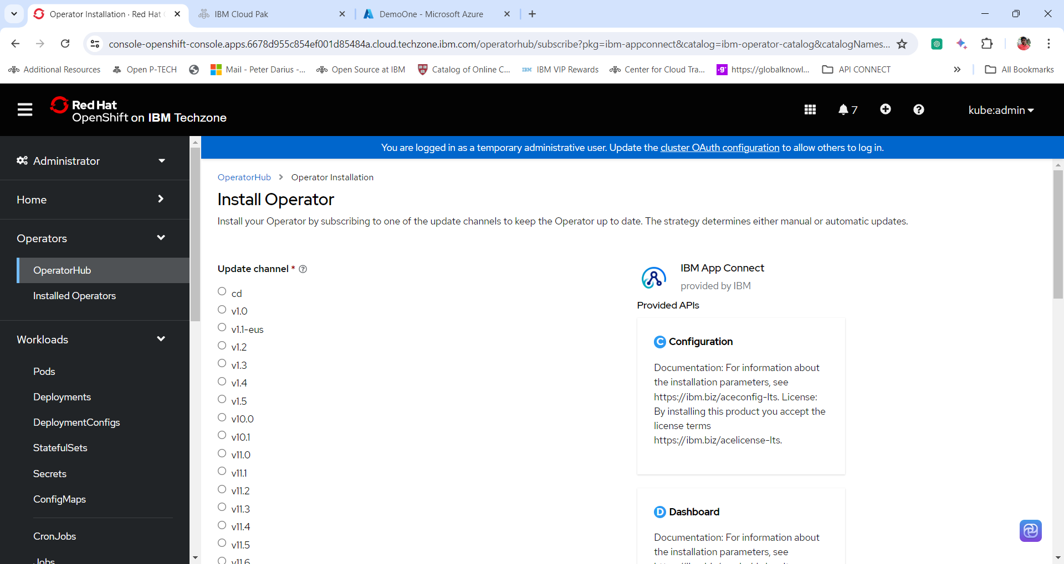

6. Select the Following configuration

**Installation Mode = All Namespace**

**Namespace = openshift-operators**

**Update Approval = Automatic**

**Click Install**

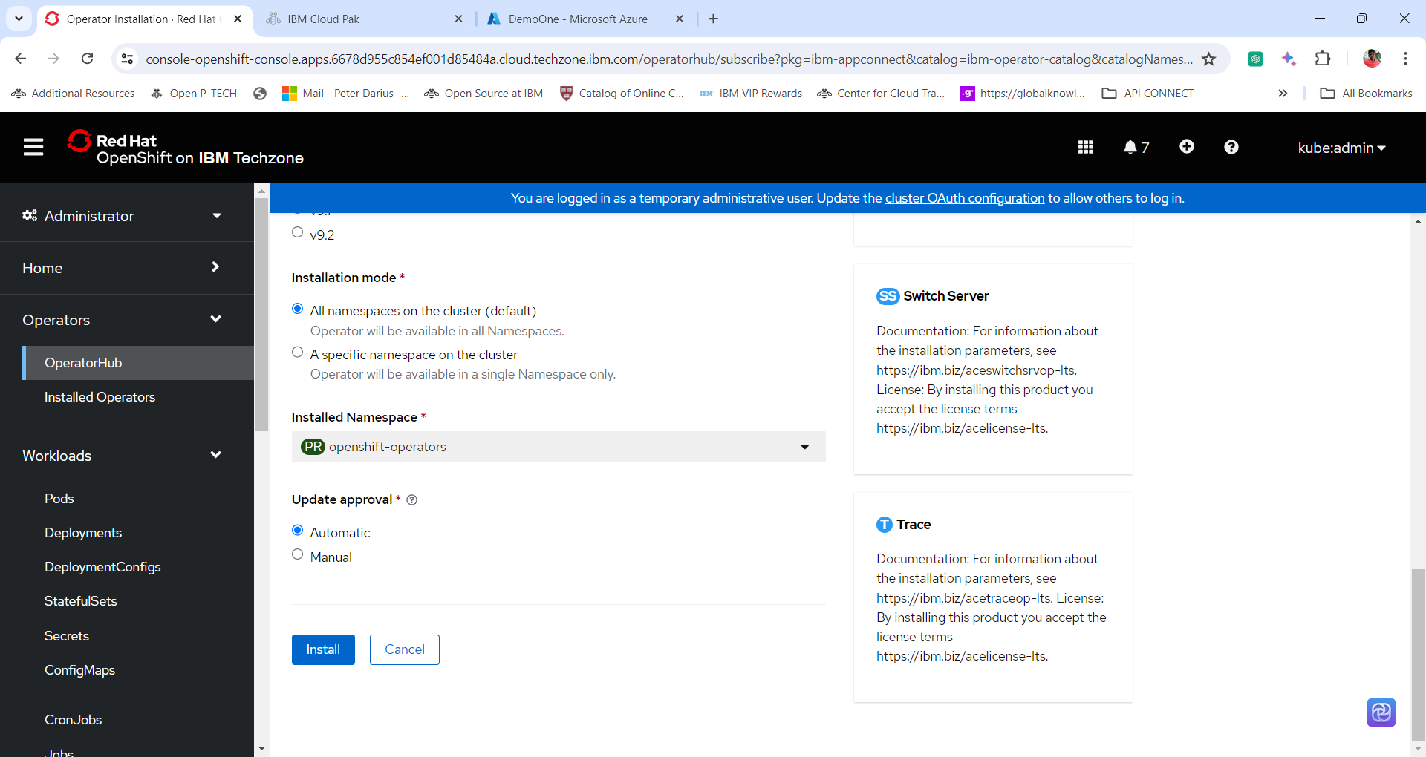

7. The Openshift Container Platform starts to install the operator. Wait for few minutes until the completion of the installation.

8. Once the IBM App Connect operator is installed and ready to use click **view operator** to view the details of the IBM MQ Operator.

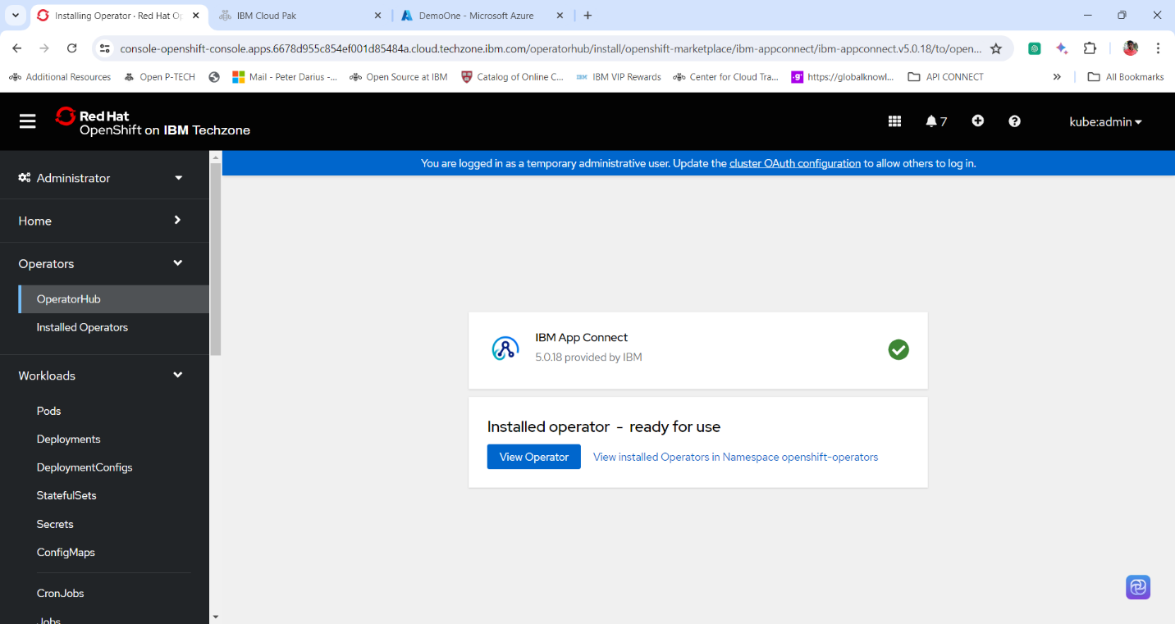

9. Go through the details of the IBM APP Connect operator.

Thanks for completing the exercise.